**Lab Test-1**

**Question1:**

**Task1:**

#Write a python program to check weather a string is palindrome or not.

**Code with output:**

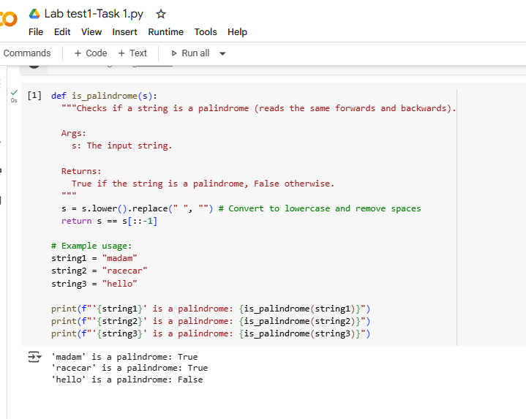

**Explanation:**

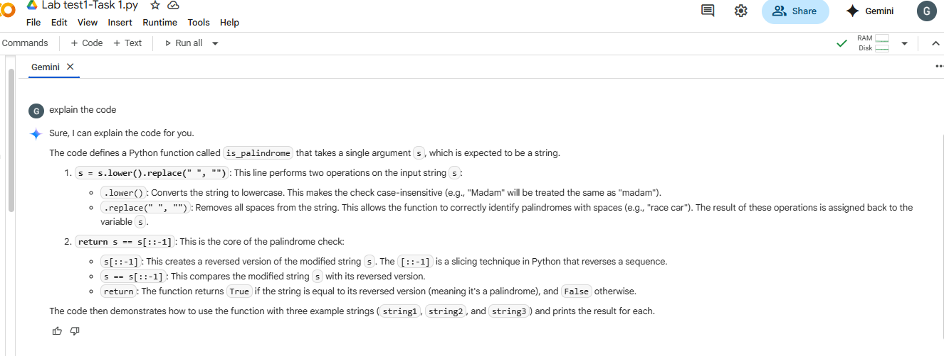

**Question2:**

**Task2:**

#give the prompt to gemini to generate a program that finds the largest and smallest number in the given list which provided by the user and ask gemini to explain the code.

**Code with output:**

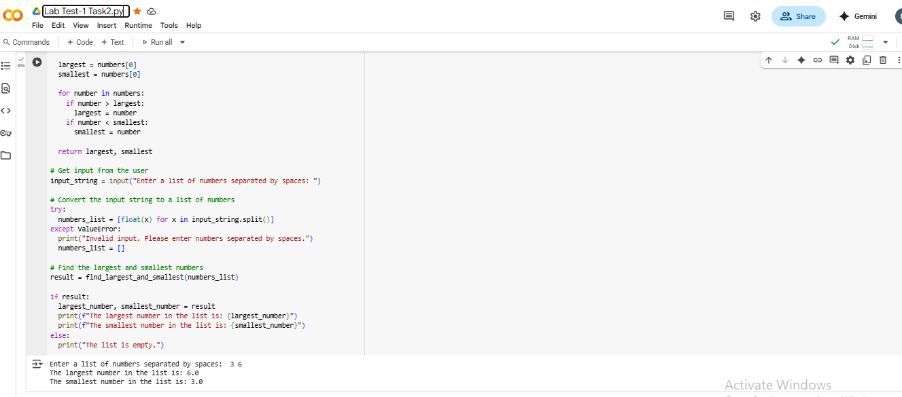

**Explanation:**

